The Lori Bie Memorial Scholarship was created in loving memory of Lori Bie to honour her remarkable kindness, positivity, and unwavering belief in others. Lori was a cherished friend and a source of constant encouragement to those around her, especially young people pursuing their dreams.
She had a deep love for nature and all living things, a strong commitment to supporting local communities, and a genuine gift for making people feel seen, valued, and supported. This scholarship is intended to reflect those values by uplifting students who share a passion for learning, a connection to the natural world, and a desire to make a meaningful difference in their communities.
A sum of $1,000 will be awarded to an Alberta student pursuing post-secondary studies. The scholarship recognizes individuals who demonstrate thoughtfulness, compassion, and a commitment to positive impact in the world around them.
PROGRAM DETAILS
ELIGIBILITY | - Applicant must be an Alberta resident.  - Preference given to students attending post-secondary studies within the province of Alberta. (We know some academic programs are not offered in Alberta, so if that is the case, please indicate that in the application)  - Must be currently enrolled in, returning to, or expected to begin post-secondary studies in September 2026.  - This scholarship is open to post-secondary students at any level (diploma, undergraduate degree, graduate studies, etc.) in all areas of study.
IMPORTANT DATES | - June 15, 2026: Application is released.  - July 31, 2026 at 11:59 PM: Application submission deadline.  - August 2026: Adjudication of applications.  - September 1, 2026: Scholarship winner announced.  - First week of September: Scholarship funds released to winner.
SUBMISSION DETAILS | - Complete applications must include the following documents:  - A completed application form  - Proof of enrollment from your post-secondary institution  - A resume or CV  - Please email your complete application to Alana Tollenaar at alana@backyardbirdsnatureshop.ca  - You may also drop off your application in store at Backyard Birds Nature Shop located at 15-100 King Street, Spruce Grove, AB, T7X 0J6.  - Submissions are due by July 31, 2026 at 11:59 PM. Late or incomplete submissions will not be accepted.
For more information about the scholarship program, please contact:
Alana Tollenaar
Owner/Operator, Backyard Birds Nature Shop
alana@backyardbirdsnatureshop.ca
780-948-8597
THE LEGACY OF LORI BIE
We first met the beautiful soul that is Lori Bie in 2021, when she walked through our store doors. From the very beginning, her presence was unforgettable. The joy, positivity, and light she carried with her cannot be fully described. She had a way of making people feel seen, welcomed, and valued. She visited us every Saturday for years, becoming not just a good friend, but a treasured member of our family.
Lori lived in the beautiful summer village of West Cove, Alberta. She loved life on the water! Whether it was a boat ride or a day spent fishing, she felt at home near and on the water, embracing every opportunity to be outdoors and connected to nature.
Lori had a deep connection to the natural world. She was a true friend not just to people, but to all creatures. Birds held a special place in her heart, and her favourite was the blue jay. From her home office window, she was often visited by flocks of blue jays. She shared her love of birds and wildlife with others freely, and it is our hope that future scholarship recipients will carry forward that same appreciation for the natural world.
Lori was a tireless cheerleader for local businesses and community. Not only did she take pride in working for a local Alberta-based business, but she also truly showed up for family-owned and operated businesses in the community. From her favourite local coffee shop to the motorcycle shops, fishing and tackle stores, and of course, the bird store, she had a routine of supporting each one wholeheartedly. She was the first to support them, the first to celebrate their successes, and the first to tell all of her friends!
Lori was deeply committed to her community. She was an active member of a nonprofit motorcycle group dedicated to advocating against child abuse. Her involvement reflected her compassion and her strong desire to protect and uplift others in meaningful ways.
Lori’s life was defined by kindness, belief in others, and a generosity that touched everyone fortunate enough to know her. We cannot repay the kindness, generosity, and belief she showed us, but we can honour her memory by extending that same spirit to others through this scholarship. The Lori Bie Memorial Scholarship is one small way of continuing her life’s legacy: by supporting young people who carry forward her values of kindness, community, curiosity, and care for the world around them.

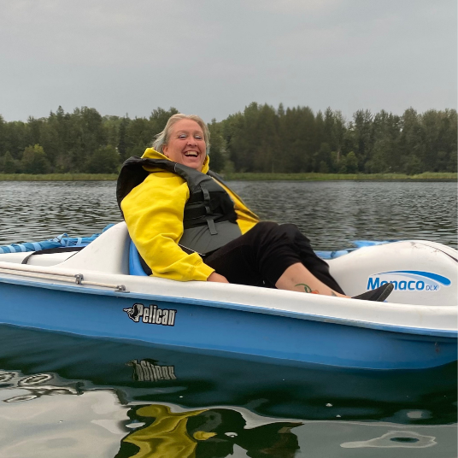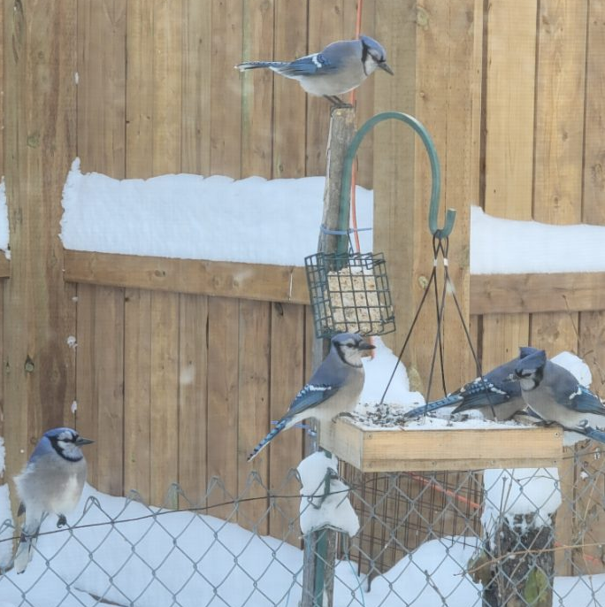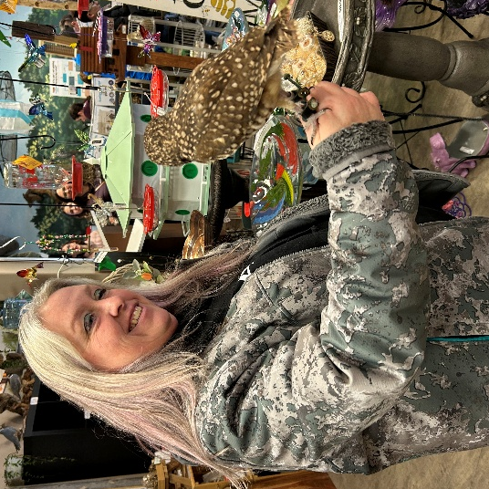

APPLICANT INFORMATION
First Name: | Last Name: | Phone Number:
Mailing Address:

City/Town: | Province: | Postal Code:
Email Address:

EDUCATIONAL INFORMATION
Name of Post-Secondary Institution:

Address of Post-Secondary Institution:

Program of Study:

Level of Study (diploma/undergraduate degree/graduate studies/certificate):

Program Start Date: | Anticipated Date of Completion:
Please note: Proof of enrollment at your post-secondary institution is required for your application. Please include a verification document (e.g., an acceptance letter or enrollment verification document) with your application when submitting.

RESUME / CURRICULUM VITAE
Please include a copy of your resume or CV with your application so we can get a better sense of who you are as an individual beyond your written responses.

QUESTION 1: Why did you choose your program of study and what impact do you hope to have on your community or the people around you through this path?

QUESTION 2: How would this scholarship help you at this stage in your life? You may wish to include any financial, personal, or educational circumstances that help us understand how this scholarship would make a difference for you.

QUESTION 3: Lori had a special connection to the natural world and living creatures. How does nature impact your life? What does it mean to you?

QUESTION 4: Lori believed in kindness, supporting others, and showing up for her community. Tell us about a time you embodied these values in your own life. How did you demonstrate them, and what did the experience teach you about the kind of person you want to be?

APPLICATION ACKNOWLEDGEMENT
I have read and understand the application and submission information, and declare that all information provided in this application is true and complete. I understand and agree that if I receive a scholarship, my name may be shared publicly to promote the scholarship program.

_____________________________________ _________________________
Applicant Signature Date

