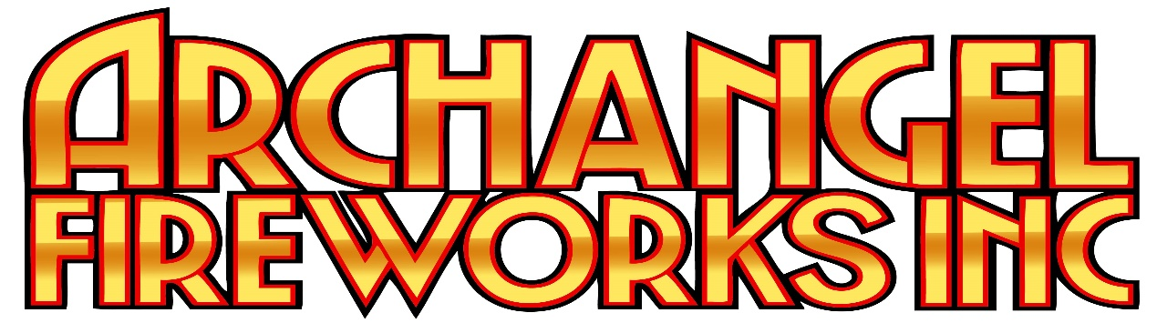

There is a difference between a License and a Permit. A license is something that is required to purchase, shoot store and handle professional fireworks, also known as “Display Fireworks”. A license is Not required for Consumer Fireworks.
A Permit is a form of permission to use a space to set off fireworks. And yes it is required.
- Why A Permit?
The main purpose of a permit is to notify those that would be required to respond in the case of an emergency. IE: Police, the Fire Department, etc.

- Which Permit Do I Need?:
Different permits exist, but for the kind of items sold at our Store at 104 Pembina Hwy, and on our website, we are talking about what is called "consumer" fireworks which requires a Consumer fireworks (Low-hazard) Permit.
Consumer fireworks are low-hazard fireworks articles designed for recreational use by the public.
Types of consumer fireworks include:
-Roman candles
-Fountains
-Wheels
-Cakes
-Mines
-One-Shots / Shells

- How Much Do The Permits Cost?
Nothing. The permits are free.
One thing to know about these permits is that they do not follow the same rules everywhere. Each city, town or RM may have their own requirements specific to their process. The best way to find out, if you don’t know, is to contact the local fire department. Contact information can be obtained online or through the town or RM's office. They can tell you what kind of permissions you need or who to ask.

We will explain the process for The City of Winnipeg.
The city of Winnipeg requires 100-feet of space all around you to use fireworks. This means that most home properties do not have the required spaces. What the city does is allow you to book a public space which grants you permission to use it for fireworks. With this permission, you can apply for a permit.
Step 1: Get permission to use a space from the city by contacting Park Bookings. If you are using a private residence or private property such as a school's field, for example, then you will need written permission from them.
How Do I Reach Park Bookings?
The best way to reach park bookings is to e-mail PWD-Park-Booking@winnipeg.ca. Permissions are handled on first come first served basis and their voicemails are not checked as often. E-mailing is the best way to reach them. They ask for 7-10 days notice.
Winnipeg's Park Booking Page
Permission Form - Blank
Once you have permission to use a space;
Step 2: Fill out and submit the Fireworks Permit to receive your permit. Remember that you are filling out the Low-Hazard Permit.
For full information regarding fireworks and the city of Winnipeg, check out this site: City of Winnipeg Fireworks (Home Page)

Once you have your permit, our staff will help you build the best show possible for your budget.

