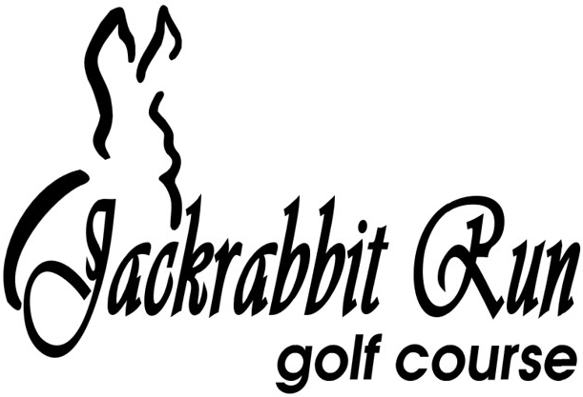

**2025 Cart Pass Agreement**

I, the undersigned, hereby agree to abide by all rules and regulations concerning the usage of a Jackrabbit Run golf cart(s) at this facility. By purchasing a Season Cart Pass or a Cart Punch Card I will be allowed to operate or ride in a Jackrabbit Run Golf Cart during normal business hours, under the rules of the day. A Cart Pass Holder/Punch Card Owner is entitled to a SEAT on a cart, not an entire cart to themselves. I am aware that I am operating the cart at my own risk of injury and am financially liable for any cart damage and/or property damage. Restrictions may be set forth due to certain weather conditions and during tournament play. Anyone driving a golf cart must be 16 years of age or older and have a valid driver’s license. Only Cart Passholders are eligible to use a seat on a cart. This agreement is not transferrable or able to be shared. Anyone else riding on a Jackrabbit Run Golf Course cart, who does not have a cart punch card will be required to pay a cart fee to ride.

* Horseplay or any type of driving which is deemed unsafe to the driver, their passengers the golf course, or to other golfers will not be tolerated.
* Carts must be kept 30 feet from greens & tee-boxes unless on a cement cart path
* Carts must be left powered on during your round. Do not turn off the power to disable the GPS units.
* Carts must be kept on the flat parts of the course-STAY OFF THE HILLS PLEASE
* As the cart passholder, you are responsible for any cart damage and/or property damage caused while you are using a Jackrabbit Run golf cart
* Observance of signs and following of daily cart rules are the responsibility of the golf cart driver.
* Failure to abide by the rules set forth in the contract above may result in termination or suspension of the Annual Cart Pass and/or Cart Punch Card without refund.

Your purchase of a 2025 Season Cart Pass and/or Cart Punch Card is contingent upon you reading and agreeing to abide by these rules. Additional rules may be added either daily, or for the season if deemed necessary by the Management of Jackrabbit Run Golf Course.