Artist Guide
BUY COLUMBIA BY COLUMBIA

WHAT IS BUY COLUMBIA BY COLUMBIA?

In 2018, ShopColumbia launched Buy Columbia By Columbia, a line of Columbia merchandise and apparel for our campus community designed by Columbia artists. Designs are collected through an online submission process and through classroom partnerships.

The goals for the line are:
- Generate revenue for ShopColumbia, partnered departments and featured artists
- Create hands on learning for the licensees
- Increase traffic to the online webstore and campus boutique
- Create unique branded merchandise that represents campus spirit

TYPES OF PRODUCTS
ShopColumbia is focusing on two categories of products:

Gifts. Columbia administration, staff, faculty, students, tourists and campus guests want to purchase unique gifts that cannot be purchased elsewhere, that say “Columbia College” and support emerging artists.

- Gifts products include: magnets, totes, notebooks, water bottles, coffee tumblers, umbrellas, blankets, zipper pouches, pens and pencils.
- Gift items may be engraved, embroidered, screen-printed or digital printed.

Apparel: Perspective, new and current students and their families purchase Columbia apparel.

- Apparel products include: t-shirts, sweatshirts, athletic and active-wear, tank tops, hats, socks and scarves
- Apparel products are screen-printed, embroidered, or direct to garment printed.

WHAT IS SHOPCOLUMBIA LOOKING FOR IN A DESIGN TO LICENSE?
- Designs that appeal to a variety of customers.
- Designs that capture the Columbia spirit, creativity and/or quirkiness.
- Designs that are cost effective to produce on products.
- Designs that can be produced on products that ShopColumbia does not currently sell.

DESIGN BASICS
- Designs must be 4 or less colors. Preference is given to designs with 1-3 colors.
- Artists can submit unlimited designs.
- Artists must be a current student at Columbia College Chicago.
- Design can stand alone or be repeated.
- Slogans or phrases that capture the Columbia spirit also welcomed.
•Designs will be printed with artist credit and copyright name and date.

WHAT TO AVOID
- “CCC” which can be easily confused with the “City Colleges of Chicago”.
- Delicate lines, less than one point.
- Designs incorporating gradients or translucent elements.

TIPS FOR DESIGNERS:
- Think about what you would wear or buy. Would you wear a shirt with your design? If not you, is there a market or a customer that would buy it?
- Design with a finished product in mind. Visualize how your design would work on a notebook, t-shirt or tote bag. Certain shapes of a design, density of color, use of lines within a design and direction of text can influence how well a design works on an object. Examples: square designs do not work on rectangular shaped items and square designs may need to be cropped if the imprint area is a circle. A design with thin lines may not scale down well on a small product. And vertical text or designs might work better on tall narrow products such as water bottles, sweatpants, or towels.
- Be flexible. The design may need to be altered (scaled up or down), simplified (number of colors decreased) or the colors may need to be changed for production. ShopColumbia may make edits with the artist’s permission.

LICENSING BASICS AND PROCESS
- If ShopColumbia staff like an artist’s design, they will reach out to the artist proposing a project with the terms of an licensing agreement.
- All ShopColumbia licensing agreements are nonexclusive and are limited by quantity, product and time duration. This means that the artist still owns their design but allows ShopColumbia to use it for the agreed purpose and time period.
- ShopColumbia will pay artists a fixed payment licensing fee for the use of the design prior to production.
- In addition to the monetary payment, ShopColumbia gives the artist a predetermined number of complimentary samples.
- The licensing fee varies based on the retail price of the product and the quantity produced. Typical fees are between $50 - $300.
- If sales of the product are successful, ShopColumbia may request to re-license the design to produce more products for an additional licensing fee.

EXAMPLES OF BUY COLUMBIA BY COLUMBIA PRODUCTS

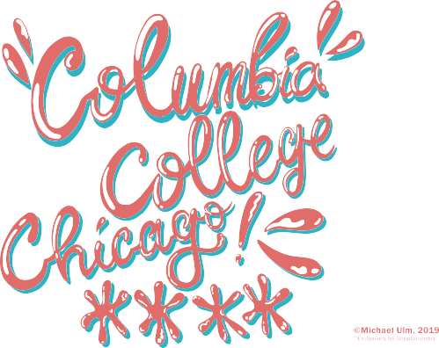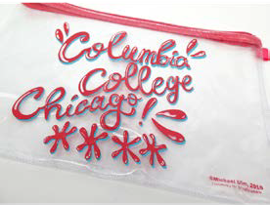
Submission by Micheal Ulm Clear zipper tote featuring design

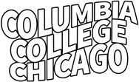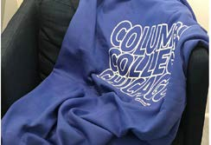

Submission by Jennifer Chavez Sweatshirt blanket featuring design

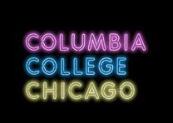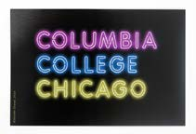
Submission by Jennifer Chavez Laptop sticker featuring design

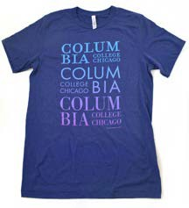
Submission by Jennifer Pollack, 2020 T-shirt featuring design

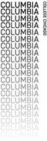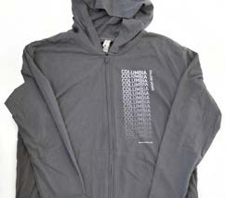

Submission by Emma Varsbergs, 2020 Hooded Sweatshirt featuring design

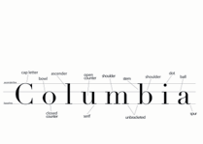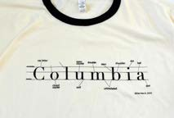
Submission by Elsa Brydalski, 2020 Ringer t-shirt featuring design

