Instructions for saving and e-mailing your completed In-Take Form (Apple)

Getting a copy of the SCA Intake Form
Download the SCA Intake Form here
After the form opens in Word, please save your document with the following title:
your name on-line-sca-intake-form.docx
Example: Valerie Blankenship on-line-sca-intake-form.docx

Filling out the SCA Intake Form
Please take the time to read the document and fill out the editable forms.
Things to look for:
If you see a check box, please click in the box to mark your answer
Example(s):
Awaiting your input
☐ Most recent CBC blood work panel and any other lab results if relevant to your health issues.

Health Issue | Severity
Click or tap here to enter text. | Click or tap here to enter text.

Filled in
☒ Most recent CBC blood work panel and any other lab results if relevant to your health issues.

Health Issue | Severity
Hard of hearing | Moderate

Helpful Hint: Please remember to hit SAVE once in a while during your input in order to save your data.

Option 1 - if you have a default e-mail set-up.
Once your form is complete, you are ready to e-mail it to Sage Woman Herbs
in the left-hand corner
Click File Share Send document
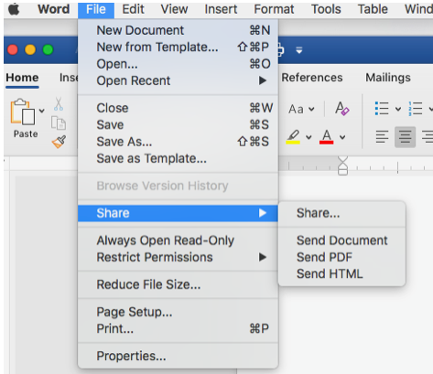
This should open up your e-mail program, creating a new e-mail. The form should automatically attach to your e-mail.

Please send your form to the following e-mail address: clinic@sagewomanherbs.com

For any questions, please contact our office at: 719-473-9702 or 833-473-4372

Option 2 - if you have web based email (examples: gmail, AOL, juno, msn) – follow these instructions:
- Open your e-mail application
- Compose a new message
- Please send your form to the following e-mail address: clinic@sagewomanherbs.com
- Title your e-mail as SCA Intake form (your name) or SCA intake form Valerie Blankenship
- Attach your intake form (example below):
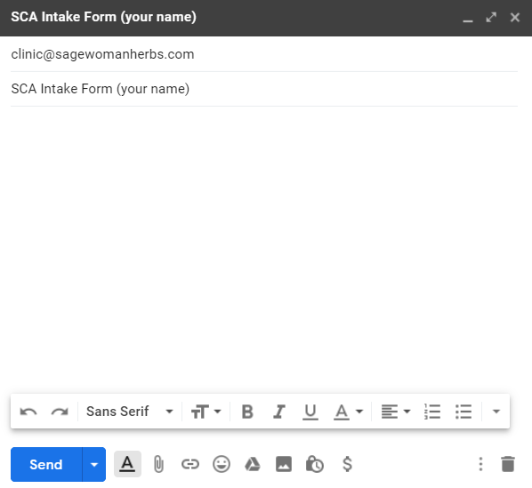

- Hit Send
- Please send your form to the following e-mail address: clinic@sagewomanherbs.com

For any questions, please contact our office at: 719-473-9702 or 833-473-4372

