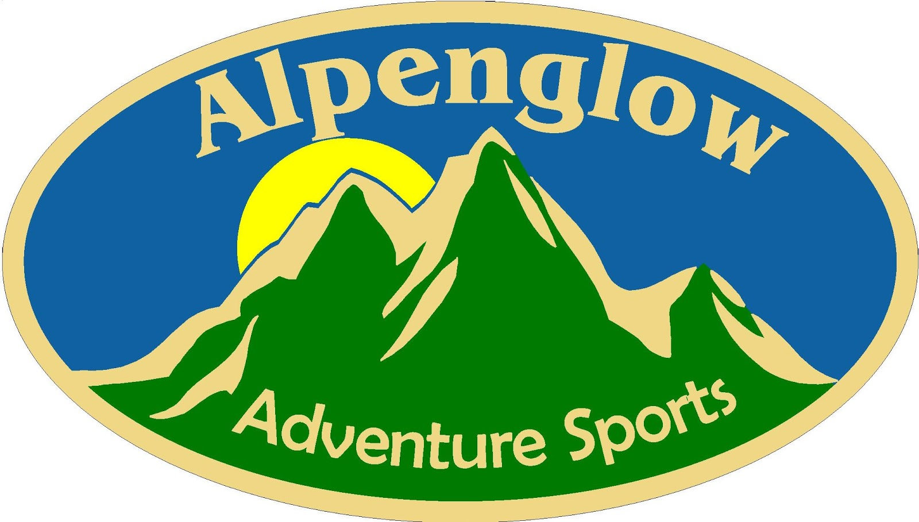
JOB ANNOUNCEMENT
April 2019
SEASONAL ASSISTANT
RETAIL MANAGER

Bar Harbor, Maine

OVERVIEW:
Alpenglow Adventure Sports, a division of Acadia Mountain Guides, Inc. has openings for energetic, out-going and highly motivated individuals with a love of the outdoors. Acadia Mountain Guides, Inc. exists to foster community and conservation through high-quality mountaineering related instruction and outdoor retail outlets. Since that time our climbing school has grown from summer rock guiding to include a full spectrum of winter programs, international trips and a youth summer camp program.

THE POSITION:
Acadia Mountain Guides, Inc. is searching for a dynamic and detail-oriented Sales and Marketing Assistant Manager that loves to sell and constantly improve themselves and their environment.

With a small core staff, the Assistant Manager’s personal sales and operational performance are central to achieving the company’s sales and profit objectives, as well as setting the pace and standard for the entire team. In effect, this position assists in the running of a climbing and mountaineering learning institution based inside of two retail stores – one based in Orono, ME, a small university community and one in Bar Harbor, home of Acadia National Park.

The position of Assistant Manager is a challenging, highly independent position offering the right individual the opportunity to manage multiple aspects of Acadia Mountain Guides Climbing School and Alpenglow Adventure Sports. It requires the right individual to make their work their priority and to work quickly, efficiently, and tirelessly to maintain and improve operating standards across the company.

GENERAL RESPONSIBILITIES:
- Assist in leading a small team of sales associates in operating the Bar Harbor retail shop and guide service reservation office
- Assist in marketing of the retail shop and climbing school through brochure distribution and social media
- Improve over prior operating paradigms and create structure and solutions where necessary
- Make use of evolving technologies to improve company performance
- Prevent and eliminate waste, redundancy, and clutter
RETAIL AND SCHOOL SALES (60%):
- Provide sales coverage through excellent customer service, operating checkout counter, processing in store sales and climbing school reservations
- Sell instructional and guided climbing sessions, summer camps, expeditions, and professional trainings
- Sell apparel, climbing gear, backpacks, tents, sleeping bags, footwear, and other outdoor related goods
- Protect company assets through loss prevention
- Maintain the highest-possible merchandising and housekeeping standards through a clean and well organized store
- Increasingly develop personal product knowledge and marketing ideas
- Design high quality in-store displays and merchandising standards
- Develop competitive promotion programs
- Evaluate and suggest new merchandise and product categories
- Act on additional directives from higher management as requested
RETAIL MANAGEMENT (40%):
- Serve as primary in-store manager of the Bar Harbor retail location
- Weekly bank deposit
- Ensure retail associates complete daily tasks by leading by example and keeping the store clean and organized
- Manage and schedule sales associates to cover the retail shop
- Oversees distribution of local marketing materials to ensure we are continually well-represented to the visiting public
- Meet regularly with employees
- Delegate a variety of assignments for sales associates
- Oversee and develop training initiatives for sales associates on products and services
- Maintains accuracy and security of both retail and climbing client data; oversees other employee’s work for accuracy, understandability and completeness
QUALIFICATIONS:
Requires excellent people skills, the ability to multitask, and an ability to work independently without a supervisor present. A first hand knowledge of outdoor activities, particularly rock climbing and hiking in Acadia National Park, and outdoor equipment or a willingness to rapidly learn is required. The characteristics we seek are:
- Has the desire to work hard and with little supervision in a fast-paced and dynamic small business
- Is extremely organized, very attentive to detail, and has analytical and problem solving skills
- Is okay spending a major portion of the day inside but looks forward to getting outside to climb and hike during time off
- Can use multiple forms of social media (Facebook, Twitter, Instagram, etc.) efficiently
- Has solid outdoor product knowledge and retail experience
- Customer service oriented and sales driven
- Is professional in appearance; confident, articulate, and comfortable speaking with customers
- Enjoy solving small problems
- Sound judgment while multi-tasking
- Ability to work flexible hours
- Must be available for all major holidays
- Comfortable with operating computer systems to include the Point of Sale system, Microsoft Word, Excel, and the internet

BENEFITS:
Wage: $15.00/hour
ADDITIONAL BENEFITS
- 30% off in-store purchases
- Professional discount through manufacturers on products sold by retail store
- 30%-100% discount on AMG professional training courses
- Variable discount on PCIA and AMGA courses

TO APPLY:
Complete our application (available @ www.alpenglowgear.com) and return it electronically with your cover letter and resume to Amanda Hatley at shop@alpenglowgear.com. After receiving your application, we will evaluate it and, if you are among the qualified candidates, we will arrange an interview. EOE.

