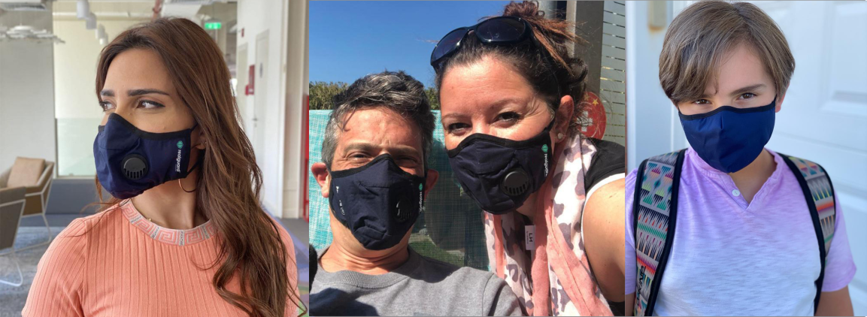
Frequently Asked Questions

What size should I buy?
Typically, Large fits most men and Medium fits most women, teens, and older children. Children sizes are arriving early September, 2020. The beads located on the ear loops also act as a means of adjustment.
For a precise size, measure the distance from the bridge of your nose under your eyes to just under your chin. Refer to the size chart below:
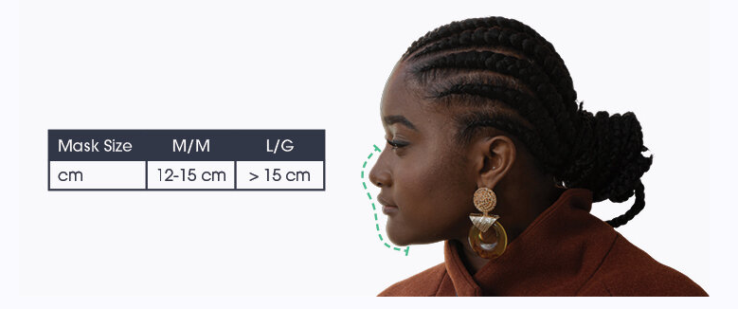
Which mask style should I purchase?
The Ultra mask (with a valve) allows for humidity to escape and reduces fog in eyewear. Note that one’s exhalation does not pass through the fabric, therefore in areas where the protection of others is mandatory, or of primary concern, the Elite mask (without valve) is a more appropriate choice.

How long can I use a RealGuard mask within a day?
RealGuard masks are designed for comfort and can be used for extended periods throughout the day.

Can I wear glasses with my RealGuard mask?
The pliable nose clip seals comfortably around the bridge of your nose preventing warm breath from rising up toward your glasses. If you notice your glasses fogging up, gently readjust your nose clip.

What is the return policy on masks?
Because of the nature of the pandemic, RealGurad masks are non-refundable. If in the unlikely event you receive the incorrect mask in a shipping error, or the product is damaged, we will provide a refund or replacement as the situation best suits.

Are there wholesale or discounted prices for a volume purchase?
Absolutely. Please contact us at sales@emergencesupply.com for discounts on orders above a quantity of 5.

Do I need a filter with my RealGuard mask?
RealGuard masks are engineered with Livinguard Technology and do not require additional filters.

Does a RealGuard mask prevent COVID-19?
The textiles treated with Livinguard technology have been tested to inactivate 99.9% of SARS-CoV-2, the virus that causes COVID-19. This protection is sustained through multiple uses and washing when used as recommended.
The use of a RealGuard mask does not substitute the need for good personal hygiene as recommended by any of the applicable authorities. It cannot guarantee against infection when mask is not worn or in instances where the virus may enter the respiratory tract through other means such as contamination through the hands.

Is the mask certified?
RealGuard masks are certified in Europe and currently imported to Canada by virtue of a Medical Device Establishment License.
Other certifications are currently in progress with Health Canada and the FDA in the United States.

How are the RealGuard masks different from other antiviral masks?
Various masks claim to be antiviral and usually rely on metal technology such as silver, copper, or zinc that can leach and become hazardous to the user and the environment.
Livinguard Technology inactivates over 99.9% of SARS-CoV-2 without the use of potentially toxic metals.

Why do face masks need anti-microbial treatment?
Bacteria and viruses including coronavirus are present in droplets and in some cases on airborne suspended particulate matter.
Surgical masks, even those that meet N95 and N99 standards, are designed to filter the particulate matter and not the virus.
Even when a mask filters bacteria and viruses, the trapped microorganisms are still alive on the mask. Recent studies have shown that SARS-CoV-2, can survive on a mask for days. This presents a great infection risk as microorganisms can transfer to your hands or other surfaces.
With the virus and other pathogens being inactivated in RealGuard masks, such risk would be mitigated.

